SEPTEMBER 2026
REBOS NEWSLETTER
Recovery • Community • Fellowship
──────────────────────────────────────────────────────────────────────────────
Have you ever been the new kid on the block, starting a new job, taking a different class, or serving on a committee?  Every organization and profession has its own language. Nurses, sports announcers, police officers, the IT department, and the military all have words, phrases, and their own brand of alphabet soup. We hear them on every medical drama and law enforcement TV show. Don’t we all know what a perp is? And btw no one uses STAT in healthcare!  Alcoholics Anonymous is no exception. When I walked into my first few meetings, I heard One day at a time. Keep coming back. Let go and let God. Easy does it. Progress, not perfection. In addition to being overwhelmed by admitting that I was an alcoholic for the first time, I felt like an alien because I didn’t speak the language. Despite this I was amazed that I was welcomed warmly by people who genuinely understood my confusion and fear. I felt safe and supported by strangers when my level of trust and faith were zero. I never felt like that before. And I needed it.  Alcoholics Anonymous provides a universal connection. One day, without noticing, we will hear ourselves saying one of those familiar phrases to a newcomer—and we realize that we are speaking AA.  The Twelve Steps, Twelve Traditions, and Ninth Step Promises are more than things we recite. They have been the foundation that guides people in recovery for almost one hundred years. They are essential maintenance tools. The Serenity and St. Francis prayers are my go-to when I am searching for peace and grace.  Step 10 - Continue to take personal inventory and when we are wrong, promptly admit it.  Step Ten is vital to helping us maintain our practice. We begin to spot check ourselves during a situation, take a daily inventory, and periodically review our progress and shortcomings. It is a good day when we realize that we are making amends quickly if we have harmed or embarrassed someone. That is major progress in working the steps. | UPCOMING EVENTS  ● LABOR DAY COOKOUT – SPONSORED BY NEW HOPE  REBOS MEETING HALL  MONDAY, SEPTEMBER 7th – 5pm  Food, Speaker & Fellowship  Please bring a dish to share  ● SOUND BATH – TIBETAN SINGING BOWLS & MEDITATION  REBOS MEETING HALL  Sunday, September 13th – 1–2pm – Michelle A  Free class – no experience necessary  ● TAI CHI CLASSES – 8 WEEKS  REBOS MEETING HALL – Starting Sept 21st  Mon & Wed, 2:30–3:30pm  Register: Danielle – 434-409-1967  ● MOVIE NIGHT – SEPTEMBER 26th @ 7pm  REBOS MEETING HALL  “When a Man Loves a Woman”  Popcorn & snacks provided.  ● CHILI COOKOFF – SPONSORED BY DISTRICT 19  REBOS MEETING HALL  Saturday, September 26th – 12–2pm  Enter your favorite chili recipe!  ● BINGO & AUCTION FUNDRAISER  Saturday, October 24th – 12–4pm  REBOS MEETING HALL  Door prizes • Food • 50/50  ● HALLOWEEN PARTY – SPONSORED BY BIG BOOK  REBOS MEETING HALL – October 30th – 7pm  Snacks • Costumes • Prizes
──────────────────────────────────────────────────────────────────────────────
──────────────────────────────────────────────────────────────────────────────

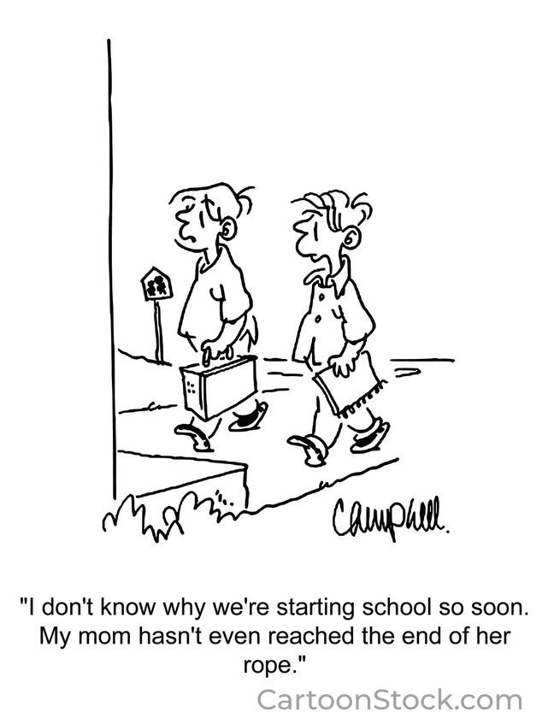 | 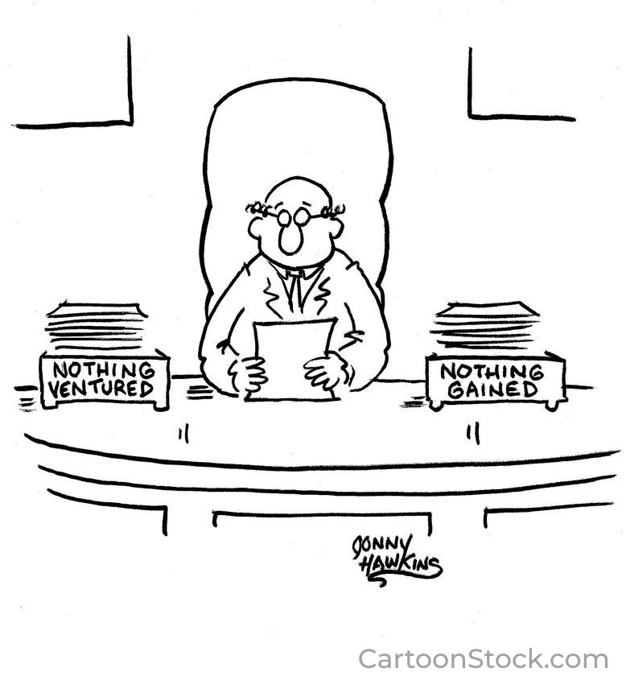
WE ARE NOT A GLUM LOT – SOME AA HUMOR
• If it is progress, not perfection, shouldn’t half measures avail us at least fifty percent?
• I don’t drink these days. I’m allergic to alcohol and drugs. I break out in handcuffs.
• I’m sorry you are such an A*@#hole does not count as an amends.

