

JUNE 2026 REBOS NEWSLETTER

If any of you have helped with a fundraiser, you know the value of volunteers who show up, pitch in wherever needed, and work together. That’s what happened on May 16th at the Rebos Spaghetti Dinner Fundraiser. Volunteers cooked, prepared food, arranged tables and chairs and assembled the to-go bags; working together like a well-oiled machine. It was impressive!
Still, the best part of the day wasn’t what was on the plate, it was the people sitting around the table.

For some, Father’s Day is joyful. For others it’s tender territory. Some of us may have grown up with fathers who were absent, battling addiction, or were just incapable of demonstrating love and affection. AA helps us break those cycles and not carry them forward.
Father’s Day is a good time to appreciate the people who did step in, showed up, and helped guide us. I have a niece who calls her stepdad her “bonus dad.”

June is busy - graduations, vacations, Father’s Day, D-Day, and Founder’s Day. Events and celebrations can mess with your routine. It’s easy to blow off a meeting or two. Right now, it may take more of an effort, but put your sobriety first; no matter what the occasion. Have a plan. Get a ride. Think it through.
AA Step 6 - asks us to be entirely ready for God to remove all of our defects of character; even the ones that we thought made us charming!
Who wants to admit that they aren’t perfect? We spend a lot of time justifying our behavior when asked to list our character defects. When I first did Step 6, my philosophy was: I drank and that’s why I acted that way. A wonderful sponsor challenged me and asked me questions that compelled me to dig deeper. I’m still digging.

UPCOMING EVENTS

Tai Chi  Classes begin June 8th  8 sessions - $120  2:30PM to 3:30PM  Rebos Meeting Hall  Contact Danielle  434-409-1967 | Founder’s Day Picnic - AA’s 91st Year  June 13th 11am-2pm  American Legion, Salem  Please bring a dish - a salad, side or dessert are always welcome.  Contact Amy H.  amyhalstead@gmail.com

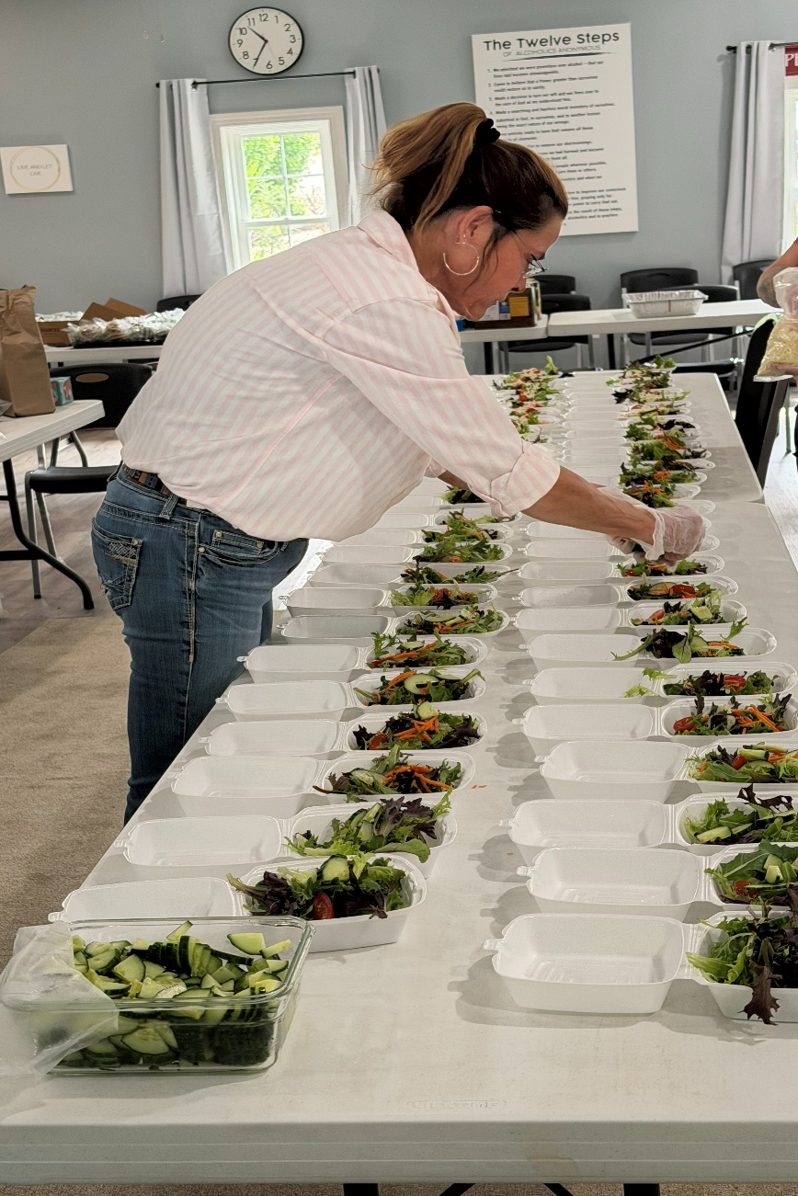

One of our main sous chefs assembling salads.

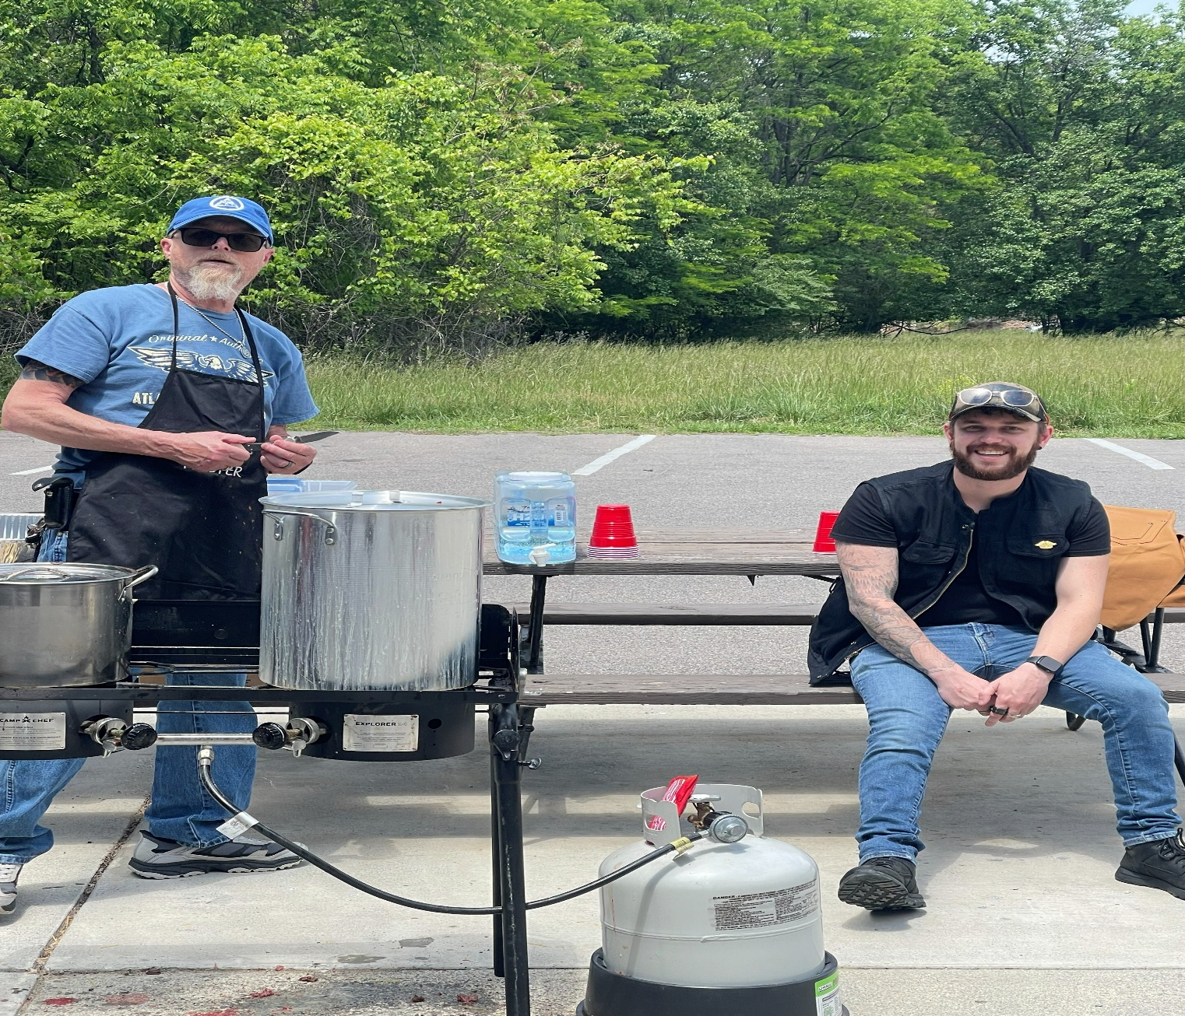

Our awesome Master Chef and his assistant.
